Data
Data is raw information. Data is a collection of unstructured raw facts, figures, or details about a person, object, or event. It can be in the form of numbers, text, images, or symbols. When data is organized and processed, it becomes meaningful information that helps in decision-making.
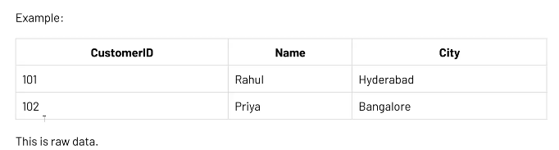
Database
A database is an organized collection of related data that is stored and can be easily accessed, managed, and updated. It helps store large amounts of information efficiently and allows users to retrieve data quickly when needed.
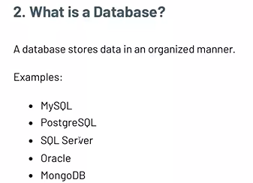
Why organizations store data?
Organizations store data in databases to keep information organized, secure, and easy to access. Databases help manage large amounts of data efficiently, reduce duplication, improve accuracy, and enable quick retrieval of information for better decision-making and business operations.
They also enable multiple users to access and update data simultaneously while maintaining consistency and security. This improves productivity, supports business growth, and ensures that important information is available whenever needed.

Relational Databases:
- MySQL – Widely used for web applications.
- Oracle Database – Popular in large enterprises.
- Microsoft SQL Server – Developed by Microsoft for business applications.
- PostgreSQL – Open-source and highly reliable.
- MariaDB – Open-source database derived from MySQL.
- SQLite – Lightweight database commonly used in mobile and embedded applications.
These databases store data in tables (rows and columns) and use SQL (Structured Query Language) to manage data.

Data Warehouse
A Data Warehouse is a centralized repository that stores large amounts of data collected from different sources within an organization. It is designed for reporting, analysis, and decision-making, helping businesses identify trends and gain insights from historical data.
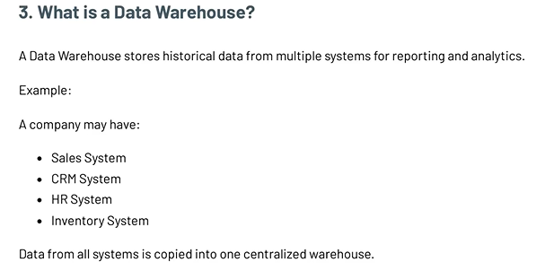

NOTES
Application must be created with minimum 3 layers
- UI layer
- API layer
- DATABASE layer
One who manage all the tree layers is known as fullstack developer
DATA Engineer Role:
A Data Engineer is responsible for building and managing data pipelines, databases, and data warehouses to ensure that data is collected, stored, processed, and made available for analysis and business decision-making.
- Importance of color (Example Red and White combination, red and yellow, red and black) Most of the app logo are in red combination because our brain’s reward point adapted to red color that when we see red color our brain produce dopamine so choosing color also important
- 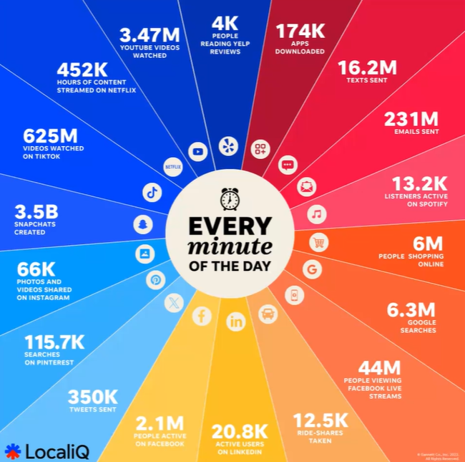
Key Responsibilities
- Collect data from various sources.
- Build and maintain data pipelines.
- Design and manage databases and data warehouses.
- Clean, transform, and organize data.
- Ensure data quality, security, and performance.
- Support data analysis and business intelligence teams
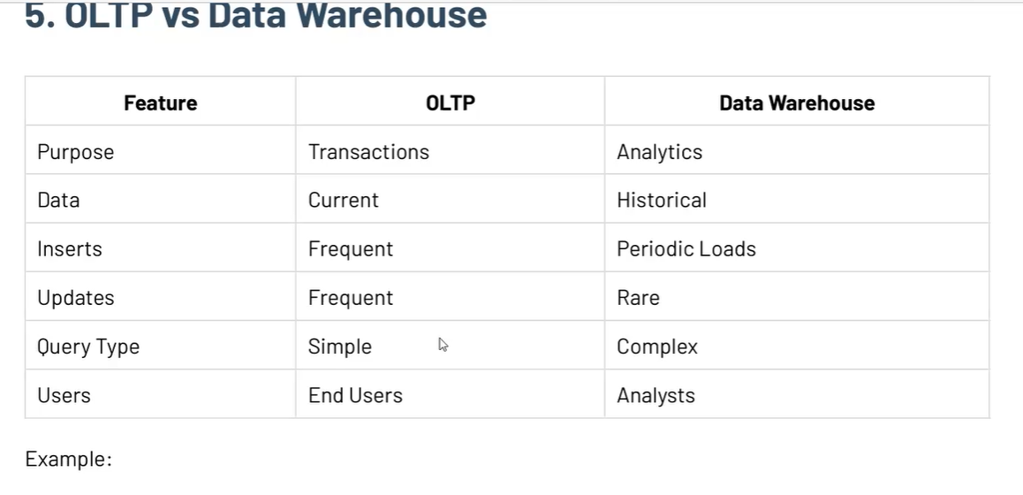
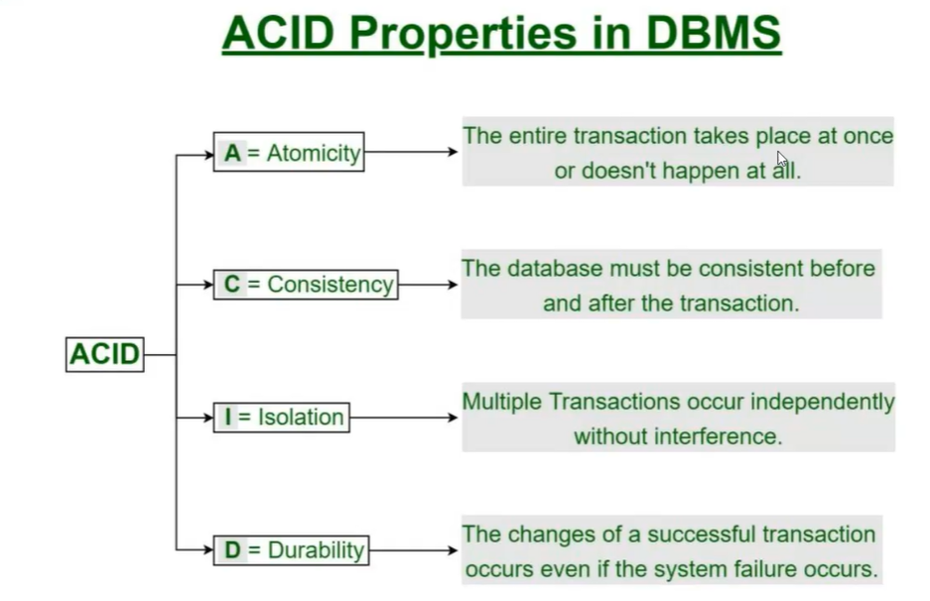
Why Represent Data in Classes?
Data is represented in classes to organize related data and behavior into a single unit. Classes make code easier to understand, maintain, and reuse. They also model real-world entities more effectively.

DDD (Domain-Driven Design)
Domain-Driven Design (DDD) is a software development approach where the design of the application is based on the business domain and its rules. It uses classes and objects to represent real-world concepts, making the software easier to understand and align with business requirements.

